Doha Meeting
“Science, Culture, and the Future of Humanity”
(May 31 – June 1, 2008)

Session II: What is the fundamental nature of the world?

The Nature of the World, and How We Fit In!”
Henry P. Stapp

1. The Basic Question, and Why It Is Important.

The basic question before us here in Doha is this:

“How do we fit in?”

“How are we human beings related to the world we inhabit?

This question is important because our beliefs about our relationship to the world underlie our values, and our values determine the sort of world we strive to create.

The problems we face today stem primarily from the fact that different approaches this basic question lead to different conclusions, and hence to conflicting values.

My topic is:

What does basic physics says about the nature of the world,
and about our connection to the world?

The conclusion is this:

Contemporary basic physics gives answers that are very different from the answers given by the “classical” physics of the seventeenth, eighteenth, and nineteenth centuries.

This is important because the changed answers lead naturally to a shift in values that could profoundly affect the future of humanity.

2. The “Classical” Approach: Materialism.

Three key ideas of the classical physics of the late nineteenth century are:

1. There exists a material universe that develops over the course of time by means of interactions of tiny material parts with neighboring tiny material parts.

2. These interactions are governed by mathematical laws.

3. These laws entail that the material future is completely determined by the material past, with no reference to human thoughts, choices, or efforts.

This conclusion is called: The principle of the causal closure of the physical!

This “Principle” seemed at one time so secure, and so central to the scientific enterprise, that some scientists came to view science as not just an open-minded empirically based inquiry into the structure of the world, but also as an ideology:

as a tenacious defender of the dogma that we human beings are essentially material systems governed exclusively by matter-based laws and hence that our conscious thoughts can have no actual effects upon our physical actions.

This dogma leads to an irresolvable conflict between science and most religions.

3. Quantum theory rescinds the materialist dogma.

Contemporary basic physics---specifically quantum mechanics---does not entail
“The Principle of the Causal Closure of the Physical!

In spite of this loss of its scientific underpinning, the classical materialist ideology continues to infect the thinking of many scientists and philosophers.

Tomorrow I shall discuss the impact upon the future of humanity
of this failure of classical materialism

Today I shall focus on the physics.

4. The Basic Conflict Between Classical and Quantum Physics.

Classical mechanics assumed that the ideas that work well for large objects, such as planets, moons, and falling apples, will continue to work all the way down to the level of the atoms and molecules.

According to this classical notion, each particle, such as an electron, has a well defined trajectory in space-time. This idea is illustrated in diagram 1.

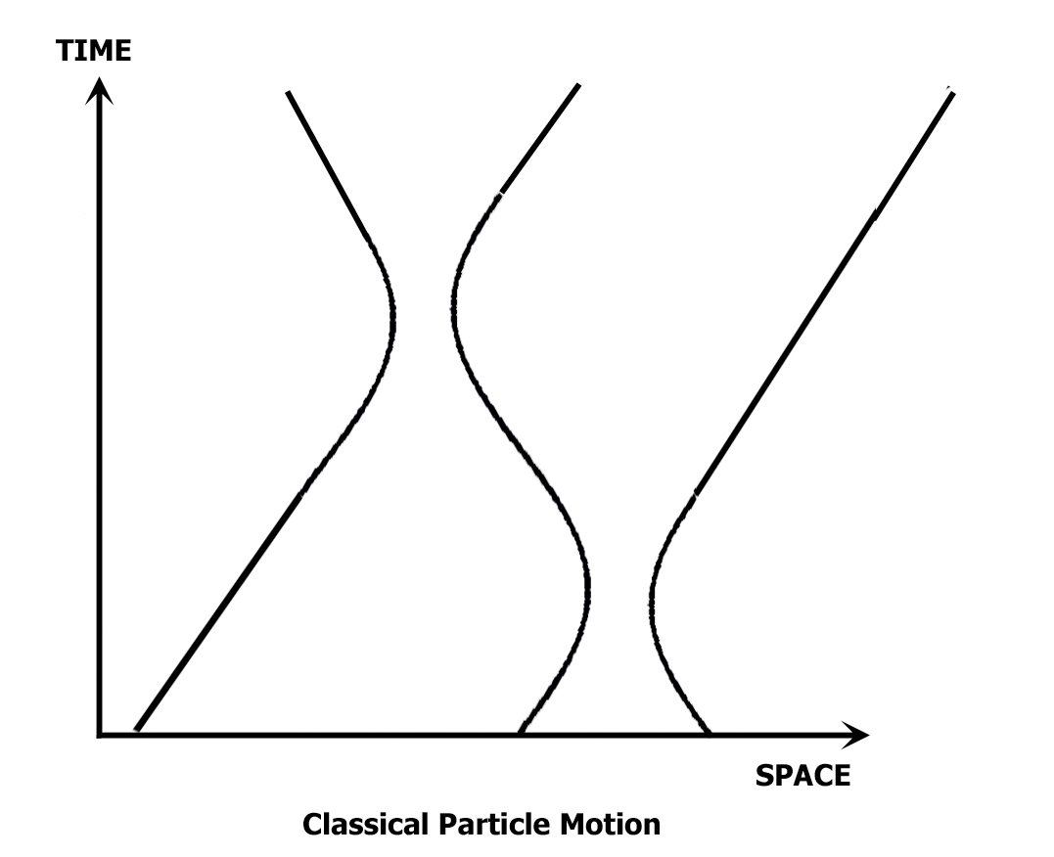

Diagram 1 shows a possible evolution in time of a system consisting of three classically conceived electrons. Each particle has a well defined trajectory in space-time, and each particle repels the others increasingly as their trajectories come closer together.

The classical-physics laws of motion ensure that the trajectories of all the particle (and fields) in the universe at times earlier than some fixed time t fix the trajectories of all particles for all future times.

A principal change introduced by quantum theory is the “quantum uncertainty principle”.

This principle asserts that each particle must be represented, NOT by one single well defined trajectory, but by a cloud of possible trajectories, as is shown in Diagram 2.
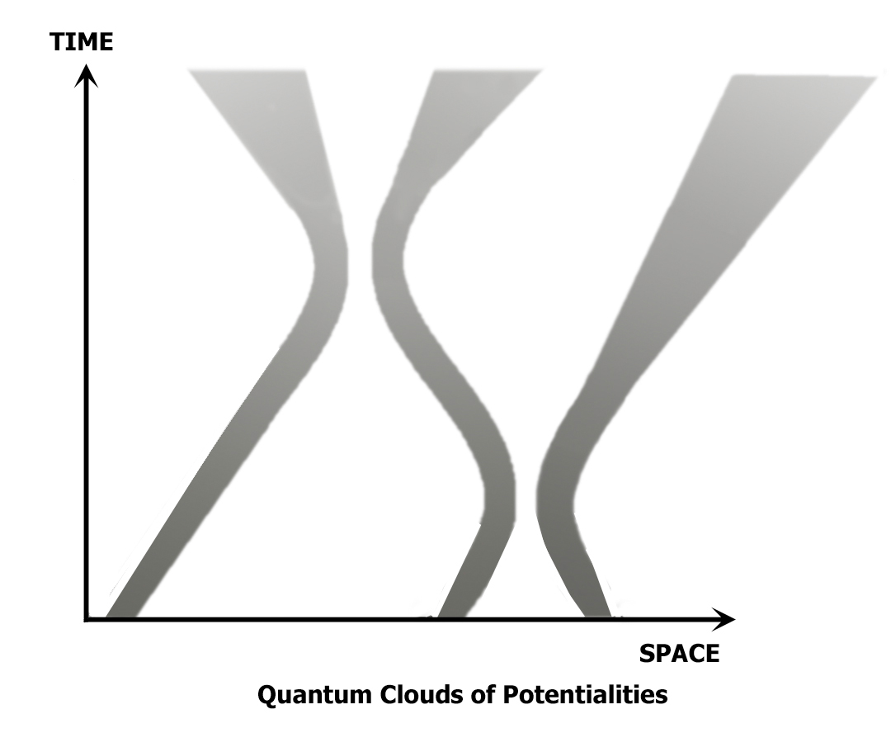

The effect of these uncertainties, if left unchecked, would be disastrous.

The uncertainties at the atomic level tend to bubble up, irrepressibly, to macroscopic
levels. If the uncertainties originating at the micro-level were left unchecked from the time of the “big bang”, the macroscopic world would be by now a giant cloud encompassing all possible worlds, in stark contrast to the essentially single macroscopic world that we actually observe.

For example, if the uncertainties were left unchecked then the moon would be spread out over much of the night sky; And each person’s brain would correspond to a mixture of all of the many alternative possible streams of consciousness that the person could in principle be having, instead of corresponding to the essentially single stream of consciousness that each of us actually experiences.

To deal with this difficulty the founders of quantum theory were forced to draw a clean conceptual distinction between the two aspects of scientific practice, the empirical and the theoretical, and to introduce a special process to account for their interconnection.

The empirical component describes our experiences pertaining to what we human beings do, and to the feedbacks that we then receive.

The theoretical component describes objectively existing “particles and fields”.

The process that connects them is called the process of measurement.

This process erects a firewall that protects the empirical realm from the unfettered intrusion of quantum uncertainties from the theoretical realm.

5. The Firewall that Holds the Quantum Uncertainties in Check

But how are the quantum uncertainties held in check?

The theory of the process of measurement was put into rigorous form by John von Neumann, building on ideas of Werner Heisenberg.

The theory demands that each experience occurs in conjunction with an associated action. This action specifies a particular psychologically understandable question that the associated experience must then answer either ‘Yes’ or ‘No’. (Multiple choice questions can be reduced to sequences of Yes-or-No questions).

Each such action is a psycho-physical event. It has two related aspects, one in the empirical domain of “our knowledge”, and the other in the theoretical domain of the mathematical description.

On the empirical side the action specifies a certain possible “increment in knowledge”:
an experientially recognizable ‘Yes’ response to the question.

On the theoretical side, this ‘Yes’ answer is linked to a reduction of the prior theoretical/mathematical state to that part of itself that is consistent with the increase in knowledge corresponding to the answer ‘Yes’.

If nature fails to deliver the answer ‘Yes’, then the prior physical state becomes reduced to the part of itself that is associated with the answer ‘No’.

This action process is represented in Diagram 3.

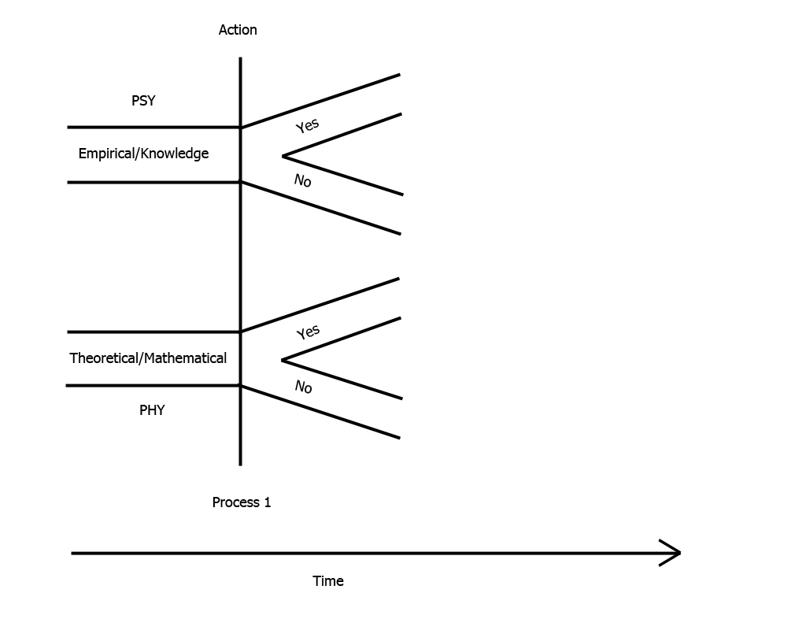
Von Neumann calls the physical part of the action by the name “process 1”.

Two important facts about process 1:

- The process 1 choices enter importantly into the dynamics.

- Quantum mechanics does not identify any sufficient physical cause for this action!

Consequently, the “principle of the causal closure of the physical” fails!

The measurement process has a second part: the Yes-or-No feedback from the associated action. This second stage is pictured in diagram 4.

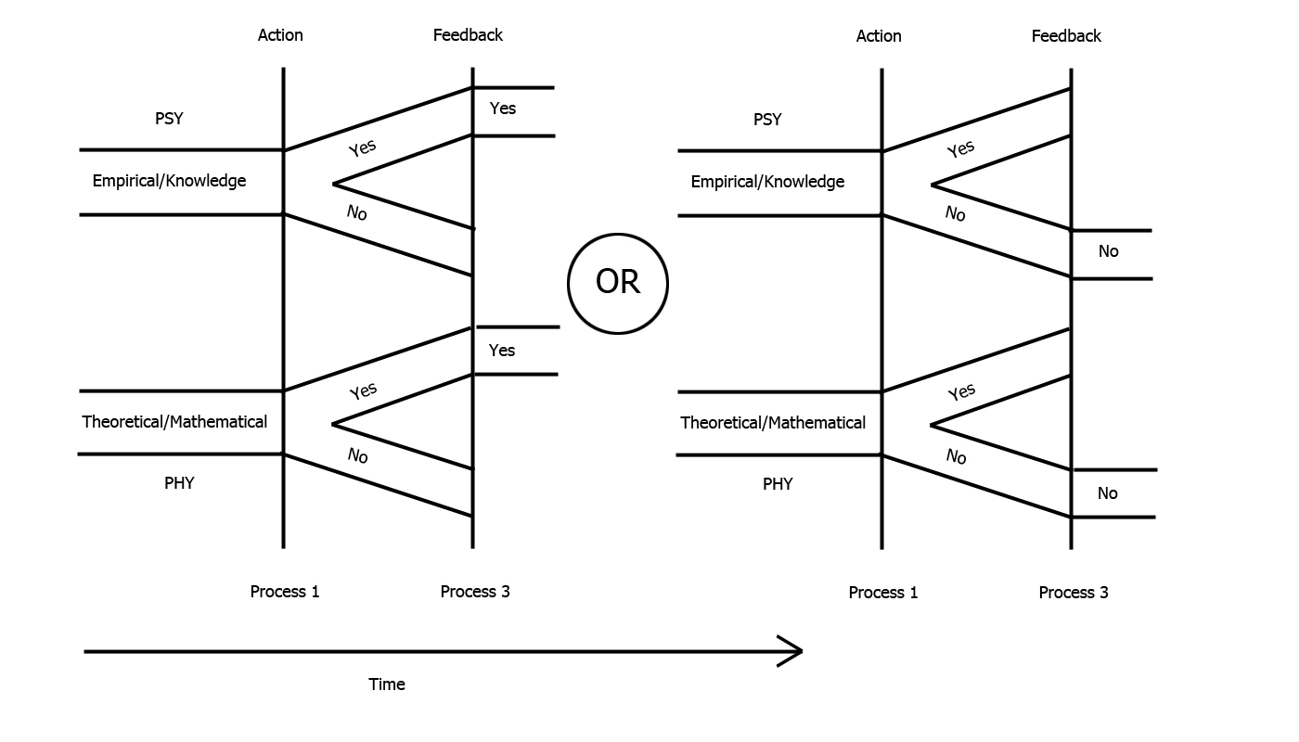

According to quantum mechanics, the feedbacks conform to statistical conditions that are specified by the theory.

The choice of the feedback (or outcome) is what Dirac called:

“a choice on the part of nature”.

According to quantum mechanics, this choice of outcome is statistical, and it lies outside the hands of human beings.

The choice of action is what Heisenberg called

“a choice on the part of the ‘observer’ constructing the measuring instruments and reading their recording.”

As regards this choice Bohr says:

The freedom of experimentation…corresponds to the free choice of experimental
arrangement for which the quantum mathematical formalism offers the appropriate latitude.”

These remarks of the founders of quantum mechanics emphasize the clear difference between the choices of outcomes, which are statistically constrained, and are beyond human control, and the choices of our actions which, in the context of orthodox quantum theory, at least appear to arise from our reasons.

The process of measurement creates a firewall that blocks the unfettered diffusion of the quantum uncertainties into the empirical realm

It is the choice of action, which is not controlled by any known process, statistical or otherwise, but which appears to be influenced by value-based reasons, that, in conjunction with a stochastic process 3 choice of feedback, controls what passes through the firewall!

6. Conclusions.

- Quantum mechanics rescinds the materialistic conception of human beings foisted upon us by classical physics.
- Quantum mechanics elevates us, within science, to agents able to act on the basis of values erected upon a science-based self-image of ourselves as partial-creators of an unfolding universe that is not controlled exclusively by the material aspects of reality alone.
- Quantum mechanics also entails that the effects of our independent individual creative efforts, occurring in spatially separated locations, are linked in ways that are incompatible with the classical concept of the causal separability of spatially separated parts. The next speaker will elaborate upon this property of quantum interconnectedness.

